Dear Friend,

For over 48 years NCAGT has had the honor of supporting gifted and talented students in the state of North Carolina. Each year we are proud to provide scholarships for some of these students who demonstrate distinguished achievement, leadership, or community service, and grants that allow teachers to introduce new ideas and activities to their students. We are passionate about supporting the needs of gifted students, especially those from underserved populations. As a 501(c)3 non-profit organization, our passion about supporting the needs of gifted students knows no limits, however, our funding to do so depends on the generosity of donors and businesses who share our desire to provide opportunities to those in the gifted community with the need for scholarships.

Like many nonprofit organizations, the pandemic has disrupted our previously predictable way of doing things and encouraged us to look at new ways for meeting needs. With this in mind, we are creating the NCAGT Annual Scholarship Fund and would like to invite you to make a donation to join us in supporting North Carolina’s brightest students who are facing their own financial limitations. You can donate by check, through our website, or by using the included QR code. The money received from these donations goes toward supporting the scholarship program and directly impacts the lives of our recipients.

Every donation helps students in our state realize their potential. It also helps inspire and empower other gifted and talented students to go after their dreams. Help us to continue this tradition in a new way and foster the future of these students and our great state.

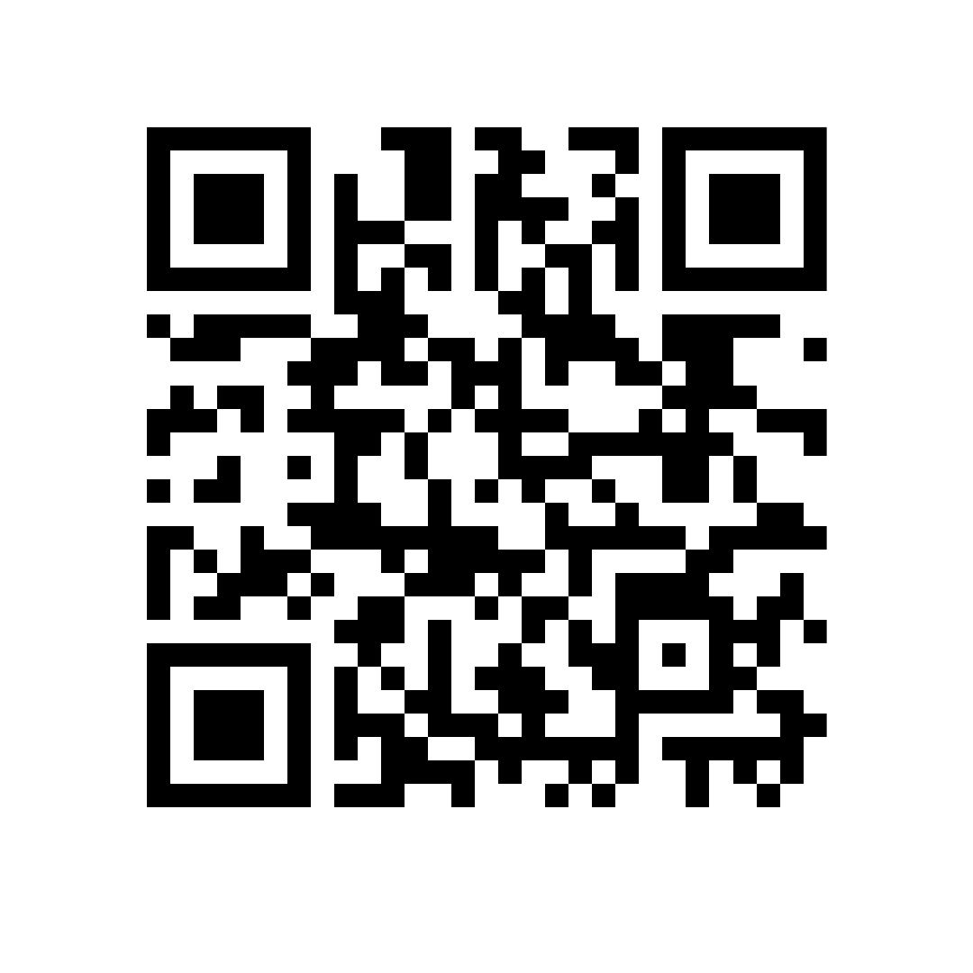
Thank you for taking the time to consider donating to this important cause.

Sincerely,

North Carolina Association of the Gifted & Talented
Board of Directors

YES, I want to help a student reach their potential! Please accept my contribution to this fund so that the scholarship program will continue for the North Carolina Association for the Gifted & Talented.

Name: ______________________________________________________________________

Agency/Company (if applicable) ________________________________________________

Address _____________________________________________________________________

Amount of Contribution ____________________

Please make your check payable to:

NCAGT
(This is a tax-deductible charitable donation)

Please mail this form with your check to:

NCAGT
P.O. Box 6
Pfafftown, NC 27040

(Optional)
This contribution is in the honor of (insert name) ____________________________________

Please note: Any donations of $1,000 or more provide the donor with the opportunity to participate in the award ceremony presentations at the NCAGT Annual Conference, March 2-2, 2023, in Winston-Salem, to receive special recognition for this gift.

Please call me to discuss special donation opportunities for the Scholarship Fund

Phone: ______________________

Thank you for your support!

